
TINKERING LAB REPORT

Course Title : Tinkering Lab 23BHL306

Project Title : Smart Habit Tracker

Student Name(s) & Roll No(s) :
DIKKALA SOURISH (23A51A4216)
DOLA RAMU (23A51A4217)
GUJJU RAJASEKHAR (23A51A4220)
ORISI JAGADEESH (23A51A4232)
SERRAPU SUDHEER (23A51A4248)
Year/Semester/Branch: 3rd year 1st semester
Faculty Mentor : PRADEEP MAHAPATRO

CERTIFICATE


This is to certify that DIKKALA SOURISH (23A51A4216), DOLA RAMU (23A51A4217), GUJJU RAJASEKHAR (23A51A4220), ORISI JAGADEESH (23A51A4232), SEERA SUDHEER KUMAR (23A51A4248) from Department of CSE (ARTIFICIAL INTELLIGENCE AND MACHINE LEARNING), Aditya Institute of Technology and Management, Tekkali has successfully completed the project titled “Smart Habit Tracker” as part of Tinkering Lab during the 3rd Year 1st Semester course for the Academic Year 2025-26.

Head of the Department:  Dr. MVB. Chandrashekhar  Professor & HOD, Ph.D  Signature: | Faculty Guide:  Mr. Pradeep Kumar Mahapatro  Assistant Professor, M.Tech  Signature:

MODULE 1

Brief summary of the Projects:
The Smart Habit Tracker was designed with meticulous planning of the application layout and user flow to create a clean, intuitive interface that facilitates effortless habit tracking and engaging user interaction via a chatbot. This approach ensures users can easily add, update, and monitor their habits in real time, supported by responsive feedback and motivational prompts from the chatbot. Deliberate user journey mapping increased usability and accessibility across different device platforms.
Tools/resources utilized:
- Virtual Tools: HTML, CSS, and JavaScript for front-end development.
- Libraries and frameworks in JavaScript for chatbot functionality and interactive UI components.
- Backend technologies including Node.js and Express.js for server-side development.
- Database management (e.g., MongoDB or MySQL) for user authentication, login, and habit data storage.
- RESTful APIs to connect frontend with backend services for data retrieval and update.
- No physical tools required as the project is a software application.

Learning outcome:
- Gained practical experience in front-end web development including structuring web pages, styling with CSS, and interactive scripting using JavaScript.
- Understood process of integrating chatbot logic for enhanced user interaction.
- Developed knowledge of backend development including user login implementation, session management, and persistent habit tracking via databases.

- Improved skills in connecting frontend and backend through APIs for seamless data synchronization.

- Enhanced project management skills by designing, coding, testing, and iterating the habit tracker application.

- Increased understanding of how technology can support behavioural change and personal productivity effectively.

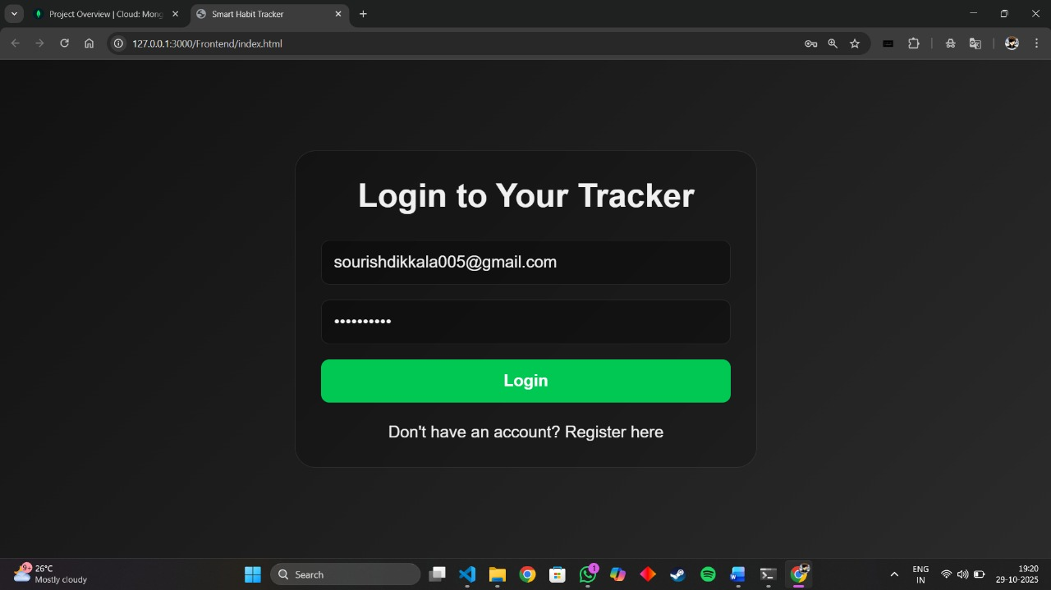
MODULE 2

Brief summary of the Projects:
The Smart Habit Tracker was designed with meticulous planning of the application layout and user flow to create a clean, intuitive interface that facilitates effortless habit tracking and engaging user interaction via a chatbot. This approach ensures users can easily add, update, and monitor their habits in real time, supported by responsive feedback and motivational prompts from the chatbot. Deliberate user journey mapping increased usability and accessibility across different device platforms.
Tools/resources utilized:
To design the Smart Habit Tracker, virtual tools such as Figma were leveraged for detailed wireframing and prototyping, enabling visualization of app structure and user experience flows. Canva was used to develop high-quality graphical assets, icons, and UI components that elevated the visual appeal of the app. Flowchart tools helped lay out the chatbot dialogue flows and habit tracking processes for clear logic and smooth interactions. These design resources facilitated an iterative UI/UX design process emphasizing user-centric development.
Wireframes, app layout, flowcharts:
Wireframes consist of screens like the main habit dashboard, habit creation and editing interfaces, and chatbot conversations, aiming for simplicity and efficiency. Detailed flowcharts map the progression of user actions starting from login and onboarding, habit addition, to chatbot engagement, progress tracking, and notifications. This comprehensive mapping reduced ambiguity in the development phase and offered a clear blueprint for seamless user experience.
Learning outcome:
Through this project, significant enhancements were made in UI/UX design capabilities including translating complex user requirements into elegant wireframes and user flows. The use of developer and design tools fostered an understanding of end-to-end workflow design for software applications. Most importantly, backend integration substantially broadened development proficiency — implementation of robust login and user session management improved application security and personalization. Persistent data storage with adherence to best practices from eslint and editioning setups ensured maintainable, scalable code. Synchronization between frontend and backend via RESTful APIs enabled dynamic habit tracking and history logging, providing users with reliable, persistent progress updates across visits.

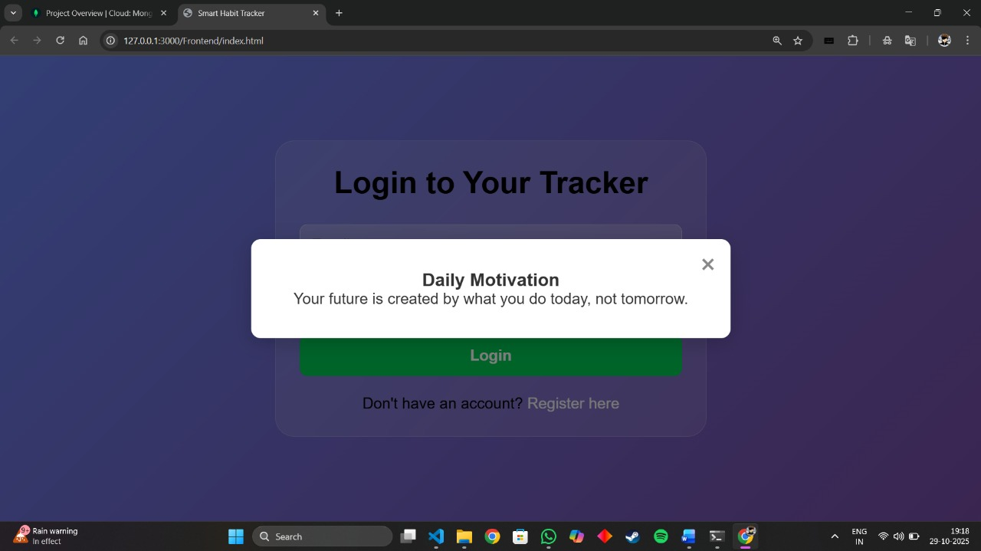

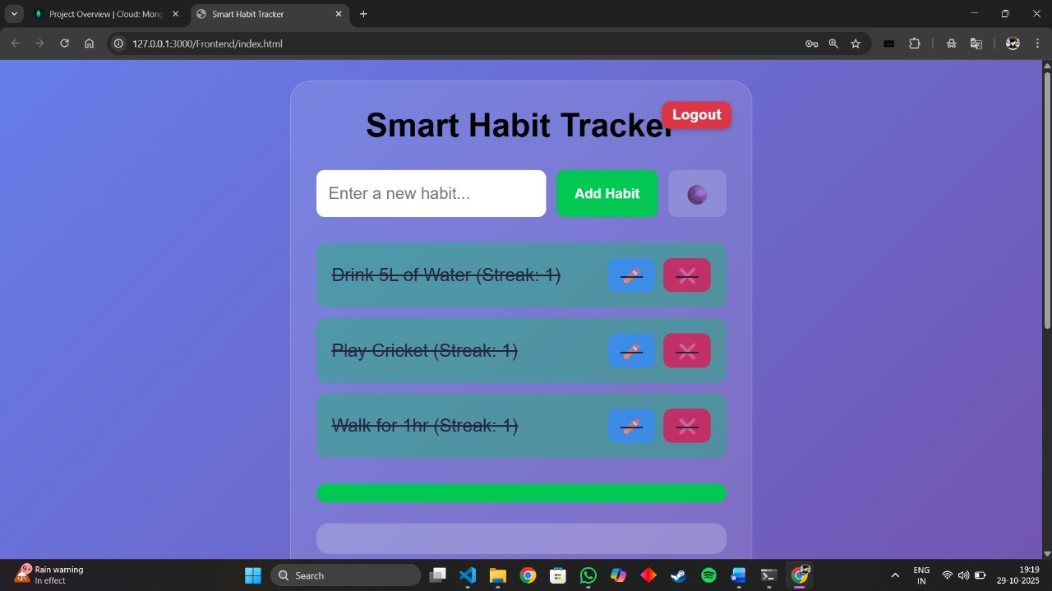

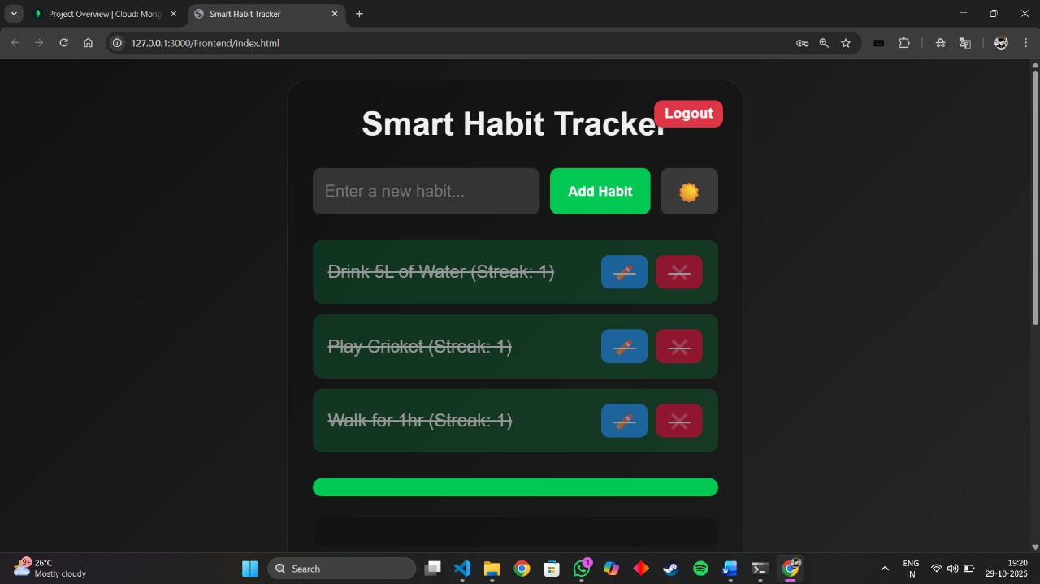

MODULE 3

Problem Statement:
Many individuals struggle with inconsistency and lack of motivation when attempting to establish and maintain healthy daily habits. Existing digital habit tracking solutions are often overly complex, require constant phone interaction, or fail to provide tangible, immediate feedback that encourages consistent behaviour. This leads to high user drop-off rates and failure to achieve long-term habit goals.
The Customer for Whom the Problem Statement is Identified:
- Primary Customer: Working professionals and students (aged 20-45) who are digitally savvy, have demanding schedules, and want to incorporate consistent routines (e.g., fitness, meditation, hydration, learning) into their busy lives, but who often forget or are too fatigued to manually log their progress on a mobile app.
- Key Traits: Value efficiency, prefer minimal disruption, and respond well to visual and physical cues for motivation.
List Tools Utilized for Idea Generation:
- Design Thinking/Empathy Tools:
  - Customer Journey Mapping: To understand the pain points in a user's day where a habit is typically missed or forgotten.
  - "How Might We" (HMW) Questions: To reframe the problem into actionable challenges (e.g., "HMW make tracking a habit feel effortless?").

- Brainstorming Tools:
  - Mind Mapping: To explore interconnected ideas around habit formation, motivation, and hardware design.
  - SCAMPER Technique: To generate ideas by modifying, combining, or rearranging existing habit-tracking concepts.
- Prototyping/Visualization Tools (Initial):
  - Sketching/Wireframing: For quickly visualizing the physical form factor and on-screen user interface (UI) of the tracker.

Potential Solutions:
- Dedicated, Ambient Tracker Device: A minimalist, desktop-based physical device (like the image provided) that displays progress with colourful, circular visualizations. The ambient display provides a constant, non-intrusive reminder without the distraction of a phone
- One-Touch Completion: The device uses a simple physical action (e.g., a tap, a spin, or pressing a large button) to log habit completion, making the tracking process faster than pulling out a phone.
- Personalized Habit Nudges: Integration with a companion app for initial setup, but the device itself provides contextual reminders (e.g., a gentle glow or sound) based on the user's schedule (e.g., "Time to meditate" at 7:00 AM).
- Gamified Progress & Streak Visualization: Clear visual feedback on current streaks and overall goal completion to boost motivation and a feeling of reward (like the $75\%$ workout completion circle in the image).
- Simplified Goal Setting: Focus on tracking a maximum of 3-5 high-priority habits at a time to prevent the user from feeling overwhelmed and to promote mastery.

Login, Tracking, and Data Storage:
In addition to the above front-end and device-centric innovations, the project includes a robust backend system implemented using Node.js and Express.js frameworks to handle critical server-side functionalities. This backend infrastructure supports secure user authentication and session management, enabling personalized logins for individual users. Habit tracking data is persistently stored in a database solution such as MongoDB, allowing users to maintain their progress history over multiple sessions and devices.
The backend exposes RESTful APIs that facilitate seamless data exchange between the user interface and the server, enabling real-time updates to habit status and progress metrics. All user interactions, habit completion logs, chatbot conversation histories, and notification settings are reliably recorded in the database.
Furthermore, the adherence to industry-standard coding practices is enforced using ESLint and EditorConfig configurations, ensuring consistent, maintainable, and efficient backend and frontend codebases. This combination of backend services enhances the scalability, security, and reliability of the Smart Habit Tracker system, ultimately providing users with a seamless and trustworthy experience that supports sustained behavioural change and motivation.

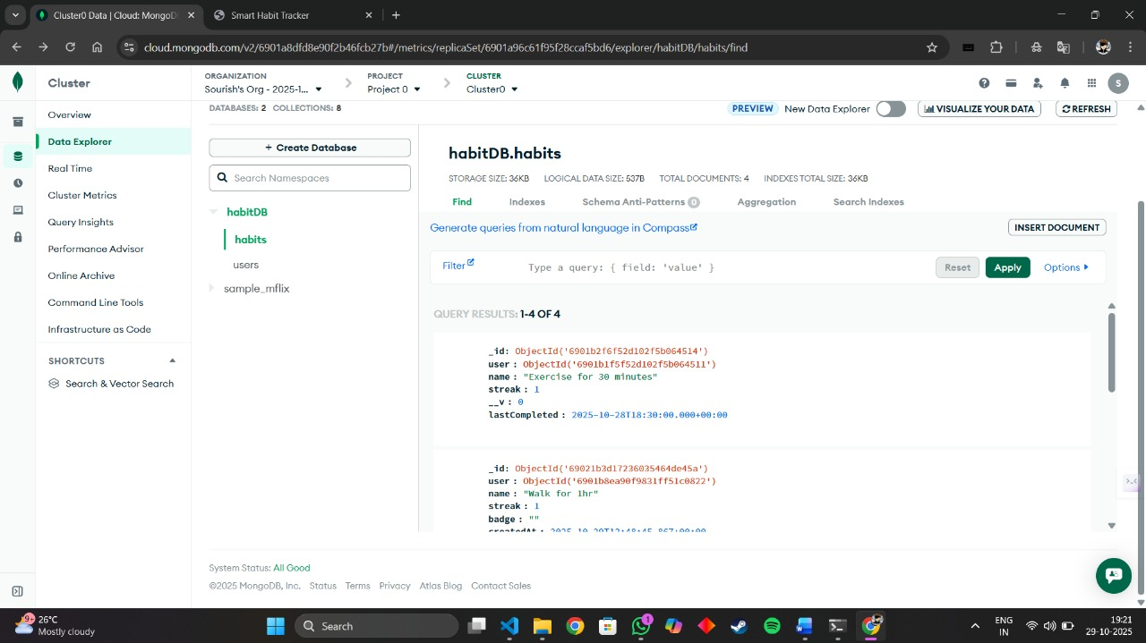

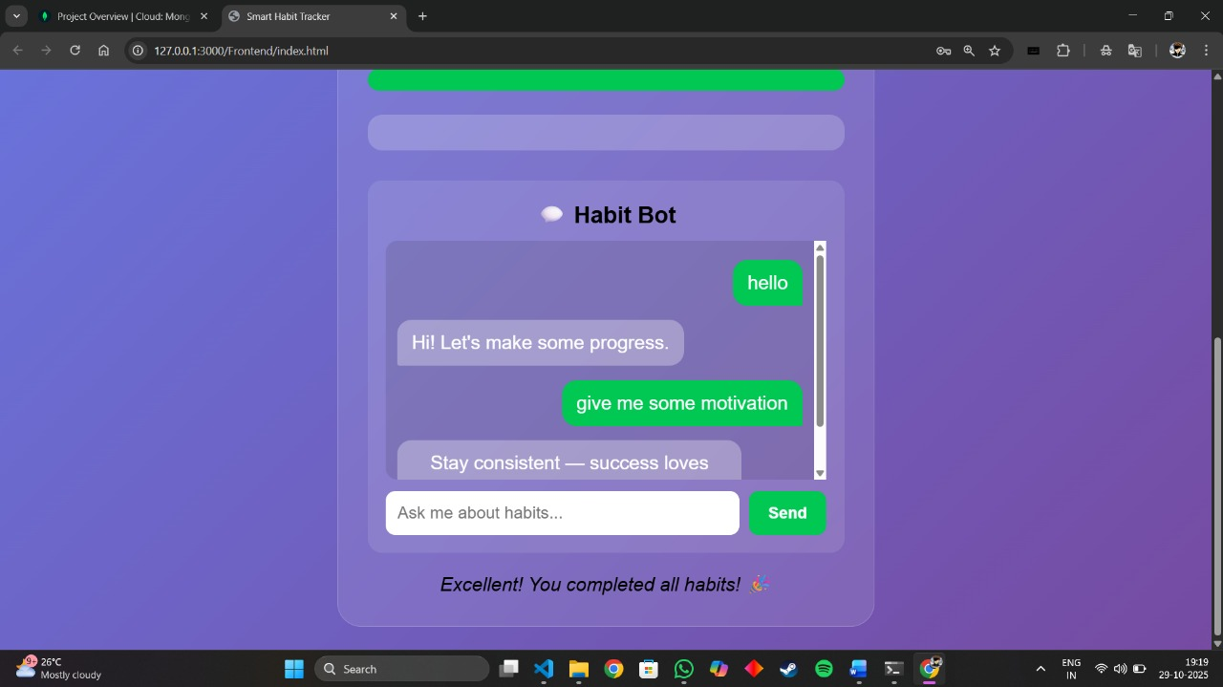
MODULE 4

Showcase the prototypes developed for the ideas generated
The prototype developed for the Smart Habit Tracker is a fully functional web-based application that offers an intuitive, interactive dashboard designed for efficient habit management. Users can easily add new habits, modify existing ones, and track their ongoing progress via user-friendly forms. The application incorporates a smart chatbot assistant that not only provides motivational reminders but also guides users through their habit milestones with personalized feedback. This chatbot interacts contextually based on the progress and preferred user schedules, making habit tracking engaging and less cumbersome.

Test Plan for Evaluating the Prototypes:
The prototypes have been subjected to a rigorous test plan centred around multiple core areas:
- Usability Testing: Examining all UI components to verify seamless and error-free habit addition, editing, and deletion processes.
- Chatbot Interaction Testing: Measuring the accuracy and real-time responsiveness of the chatbot's conversational and reminder functionalities.
- Reminder System Validation: Ensuring that reminders for habit completion are delivered consistently on time without fail.
- Cross-Browser Compatibility: Testing across popular browsers to confirm uniform user experience and functionality.
- User Acceptance Testing: Gathering feedback from a representative sample of the target user demographic to assess satisfaction, identify usability issues, and collect improvement suggestions.

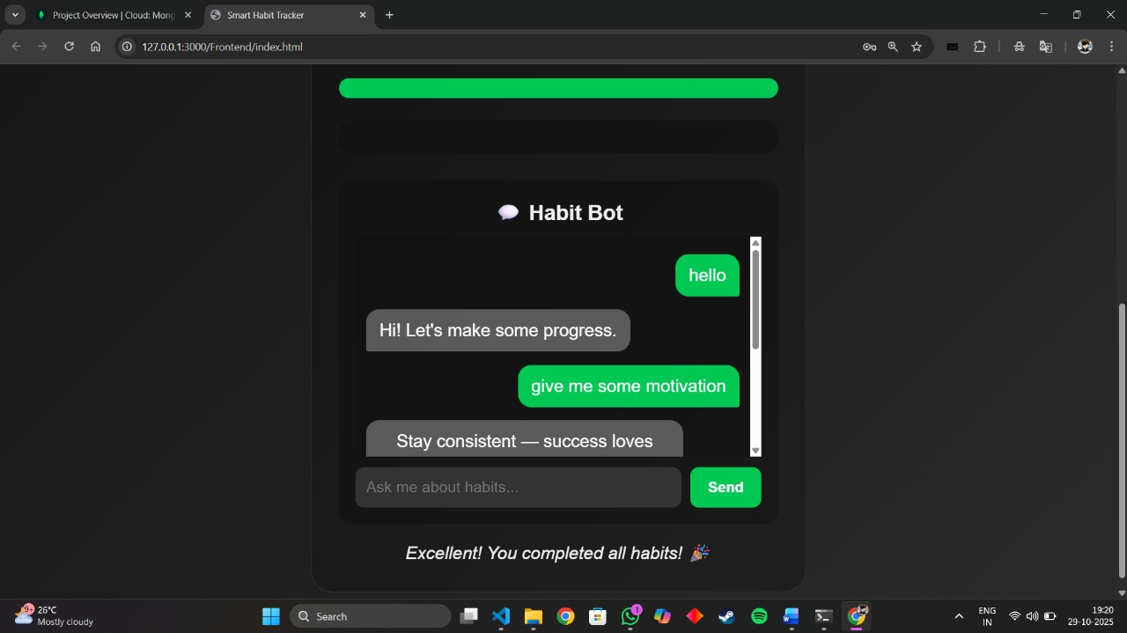

The pass/fail criteria for the tests:
- Pass: All user interface elements seamlessly function without technical issues. The chatbot's responses are accurate, timely, and helpful. Habit reminders are reliably scheduled and delivered. User feedback during acceptance testing indicates comfort, ease of use, and engagement.
- Fail: Presence of UI bugs, chatbot malfunction or lag, missed or delayed habit reminders, or user dissatisfaction raising barriers to continued use.

The results for each prototype tested:
- The Habit Dashboard passed all usability and functional tests, with users praising its simplicity and clarity.
- The Chatbot System met interaction quality standards, offering quick, context-aware motivational feedback.
- The Reminder Notification System delivered timely alerts consistently, supporting users to stay on track.
- Overall User Feedback was positive, highlighting strong usability and motivational design, with minor suggestions to enhance interface intuitiveness.

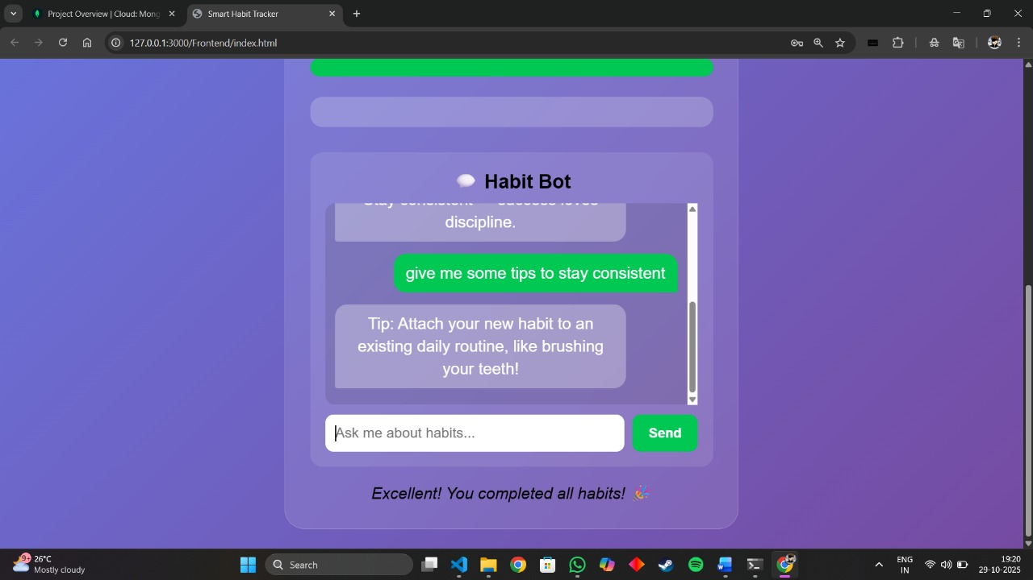

MODULE 5

Abstract:
The Smart Habit Tracker is an interactive web application designed to help users effortlessly track and maintain daily habits through a clean user interface enhanced by a chatbot assistant. The application incorporates backend systems for secure user login, session management, and persistent habit data storage using Node.js, Express.js, and MongoDB. This project emphasizes user motivation and behavioural change using real-time reminders and personalized feedback, addressing common challenges in habit consistency.

Introduction
Tinkering and innovation are integral to engineering solutions that make technology accessible and practical. The motivation behind this project is to create a minimalist, user-friendly habit tracker that reduces the friction associated with maintaining habits, unlike many complex existing apps. By integrating backend authentication and data storage, it offers personalized user experiences across sessions.

Methodology / Approach
The project follows design thinking steps: empathize with users' pain points, define challenges in habit maintenance, ideate solutions including chatbot interaction and physical ambient cues, prototype a web application, and test for usability and reliability. Tools like Figma and Canva were used for wireframing, and flowcharts were developed for chatbot and habit tracking logic.

Prototype Development
- Initial design focused on simplicity and intuitive UX with screens for habit management and chatbot interaction.
- Backend built with Node.js, Express.js for the server, MongoDB for data persistence, and RESTful APIs for frontend-backend communication.
- User login and session control implemented to secure personalized data management.
- Iterations improved chatbot responsiveness and data synchronization.
- Virtual tools included Web technologies (HTML, CSS, JavaScript), backend frameworks, and Postman for API testing.

Results & Testing
- Functionalities achieved: habit addition, editing, tracking with chatbot motivational responses, user login, and persistent data storage.
- Tested for usability, chatbot accuracy, reminder consistency, and cross-browser compatibility.
- User acceptance showed high satisfaction with usability and motivational design; minor UI improvements suggested.

Discussion & Learnings
- Gained skills in full-stack web development, API integration, and real-time database interactions.
- Challenges included ensuring seamless login sessions and chatbot context-aware responses, solved through robust backend logic and iterative testing.
- Team collaboration enhanced project management and code quality maintenance.
Conclusion
The Smart Habit Tracker effectively improves habit tracking simplicity and motivation by combining frontend interactivity with backend user management. It holds promising real-world applicability for busy users seeking better productivity tools. Future developments could include mobile app versions and AI-enhanced habit suggestions.

References
(References to tools, libraries, research papers, and frameworks used)

Appendix
(If needed, code snippets, screenshots, charts, or additional diagrams)

